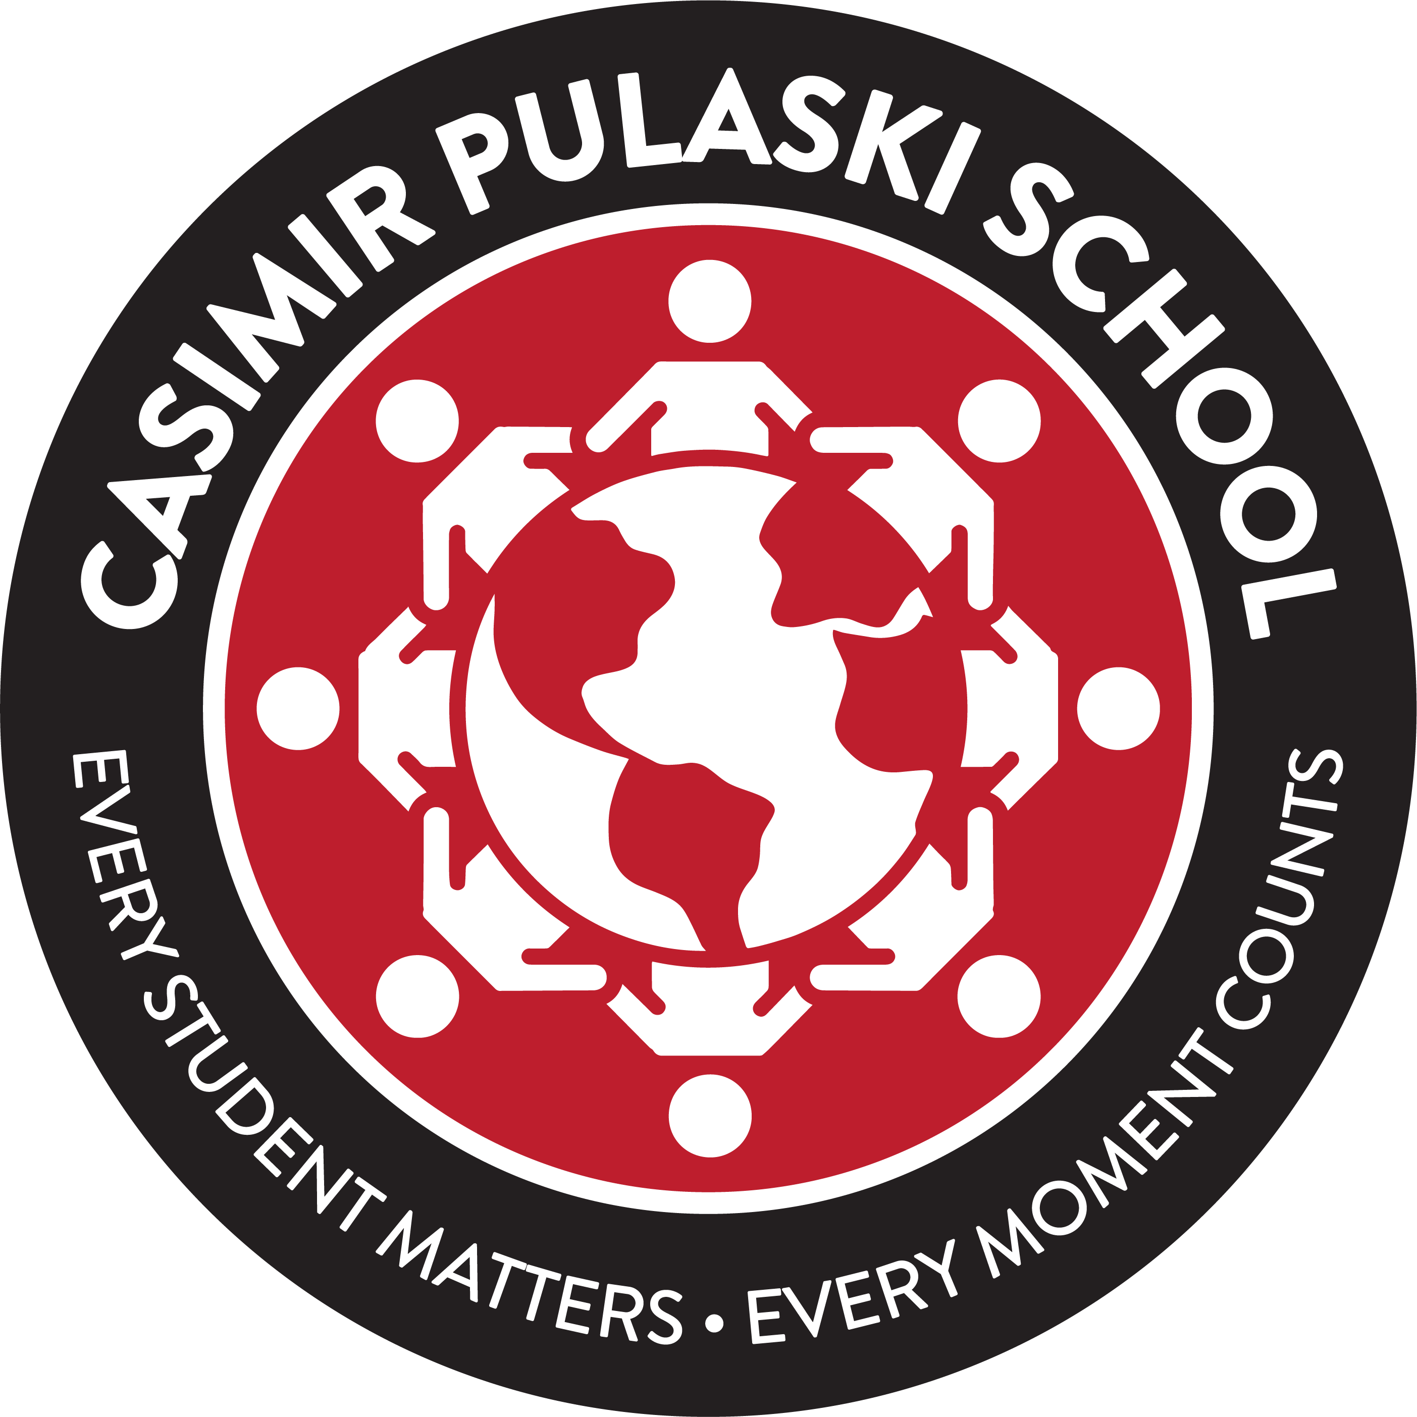

Casimir Pulaski

Mission Statement

At Casimir Pulaski School all children are expected to achieve academic excellence. Students are empowered to be life-long learners and independent thinkers.

It is our mission to challenge all students and foster a love of learning in a caring, supportive environment. Our culturally diverse student body is provided with a solid foundation of the skills and knowledge necessary for educational success in our global society.

These goals will be achieved through successful partnerships with home, school and the community in an atmosphere of trust and cooperation.

Vision Statement

Casimir Pulaski is a diverse community of lifelong learners who excel and positively contribute to the community.

There is a strong commitment from all stakeholders to build bridges for the academic, social, and cultural excellence of all students.

